AGODA BOOKINGS

This Power BI Dashboard is been is Created using the Dataset Which is been provided by the Company.

This Dataset basically gives us the Host Accommodation in the particular city in Year wise, the amount of Revenue collected, customer Satisfaction.

There are Total of 10 Cities Provided in the Data Set.

* Paris
* Istanbul
* New York
* Sydney
* Mexico
* Rio de Janeiro
* Rome
* Bangkok
* Cape Town
* Hong Kong

The Data is being provided for 14 years starting from the year 2008-2021.

From the Dataset Provided I have Created some Power Bi Visuals for the Explanation of the Data and to provide a good Inference.

It is Always Better to Understand the Given Data set and provide useful insights to the CEO of the Company so that He/she can understand what is the Trend analysis and can Improve his/her Business.

Power BI is a unified, scalable platform for self-service and enterprise business intelligence (BI), it is very useful in presenting Data in more Attractive ways.

From the Above Data set Provided we have found out various Measures and also represented in various types of visuals so that the user can Understand the Data very well.

The Dataset Usually Contains Data for the

* Number of Listings
* Name of the Host
* Host Id
* Host since the Date of Staying in the Room
* City
* Latitude
* Longitude
* Property type
* Number of Accommodates
* Number of Bedrooms
* Maximum &Minimum number of Nights stayed by the Host
* Amenities
* Reviews

Using the Above Data, we are going to find the Useful Insights for Better Understanding of the Data and provide a good Analysis.

We are going to use various types of Visuals to represent the Data in a Very Attractive Manner to Understand them very well.

We are Also Going to find the following things

1. Total number of Host living
2. Total Revenue Collected
3. Total User Reviews collected
4. Total number of Bedrooms
5. Total Number of Accommodation
6. Which city is Very Suitable for Starting a Business.
7. What are the Useful insights that can help in Developing the Business
8. To find the Trend Analysis year wise.

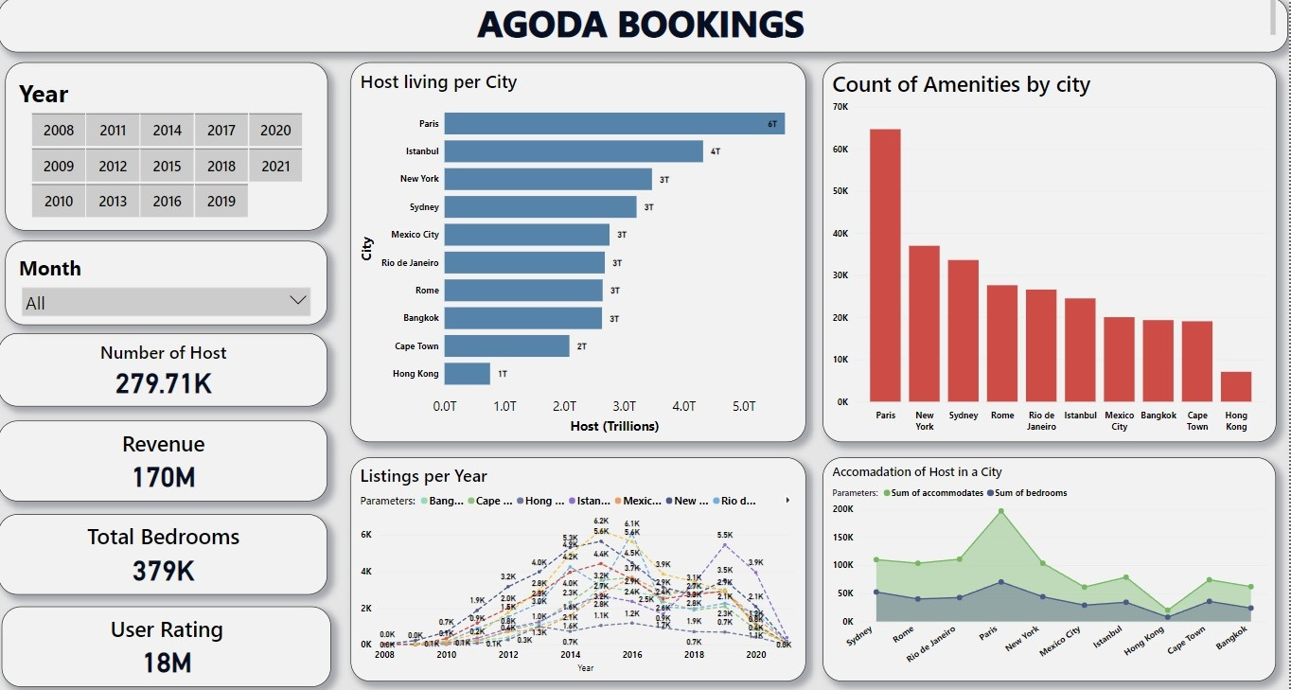

The Main page of the Dashboard which provides the Analysis of Data based on

* Host Living Per City.
* Number of Listings per Year.
* Count of Amenities in each City.
* Accommodation of a host in Particular city.
* Paris has highest number of Host Living whereas the lowest is Hongkong.
* As Paris has the Highest host Living it also has the high count of Amenities (Tv, Heater, Long stays allowed, Dishwasher, WIFI)
* City Paris has the Highest Amount of Listings Bookings in the year of 2015 (45K) and then decreases as the years pass by whereas Istanbul has a trend in increase in Bookings from the year of 2018 and then it maintains a stable record till date.
* The sum of Total Accommodation is Always Greater than the Total number of bedrooms Available.
* We have found out that the Total number of Host who have booked hotels are around 280K.
* The Total Revenue collected is around 170M.
* The total number of Bedrooms Available are 379K.
* The Overall user ratings are around 18M.

# **Accommodation**

# 

* This Page shows the Detailed report of the Number of Accommodation of the Host in the particular city.
* There are total of 280K accommodation in total of all the city.
* Paris has the highest amounts of bedrooms available with a total of 80K and the lowest is Hongkong with a total of 8K bedrooms.
* There are actually different types of properties available for the host to live in, the count of accommodates is also calculated in and represented in the tabular form.
* Apartment has the Highest amount of Accommodates.
* Count of Accommodates is very high in City Paris, and it very low in Hongkong.
* The Accommodation in Paris is around 65k and Hongkong has the lowest count of 7K.

**Revenue**

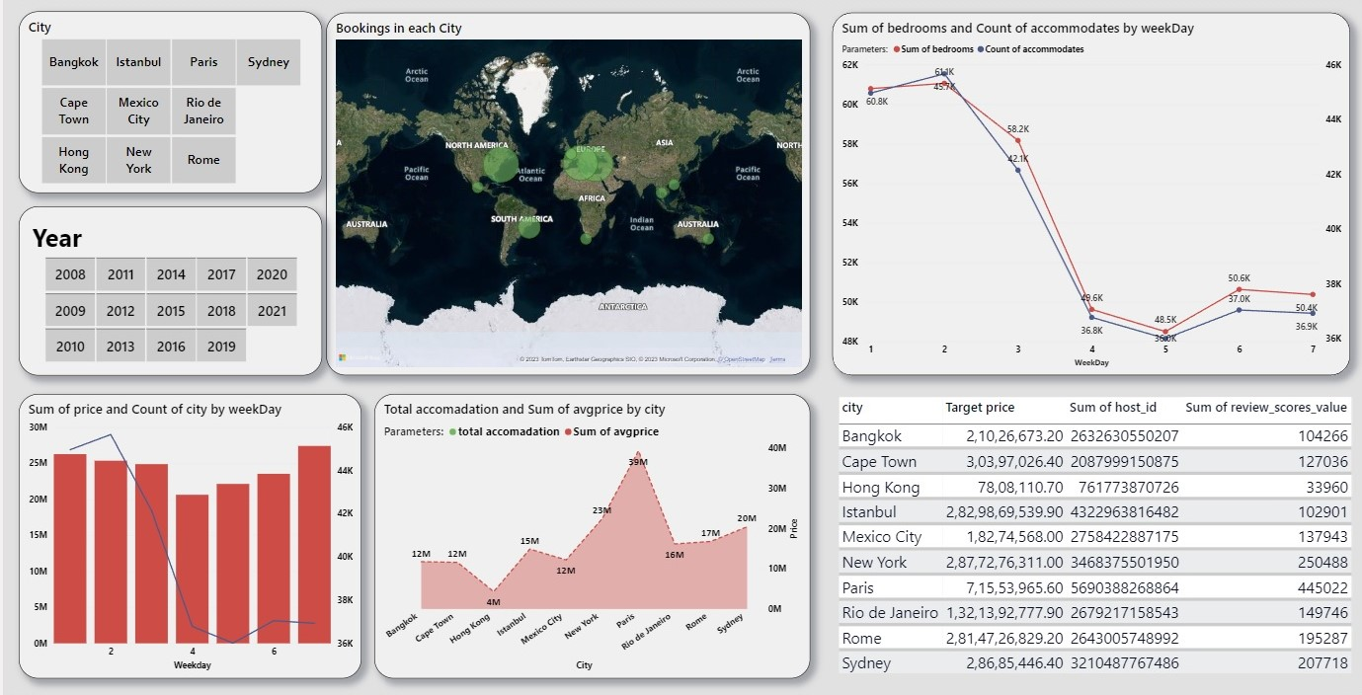

This Page Shows the detailed report of the Revenue Collection in the Each City.

* It also shows the overall bookings in Each city in a geographical way.
* This Page shoes that the Monday has the more number of Accommodation by the Host whereas Thursday is the very minimum number of bookings
* The Average price is very high n the City Paris and the Revenue collected is around $39M.
* There is a Table Present in this Page which shoes the overall report of total number of Cities, Revenue collected, total number of Host Present in each city, total reviews posted by the user.
* Hong Kong has the Lowest average income of $4M.
* The Total price collected in the Each City is always Higher in Monday Than Compared to other days, Thursday has the lowest collected Revenue.

**Reviews**

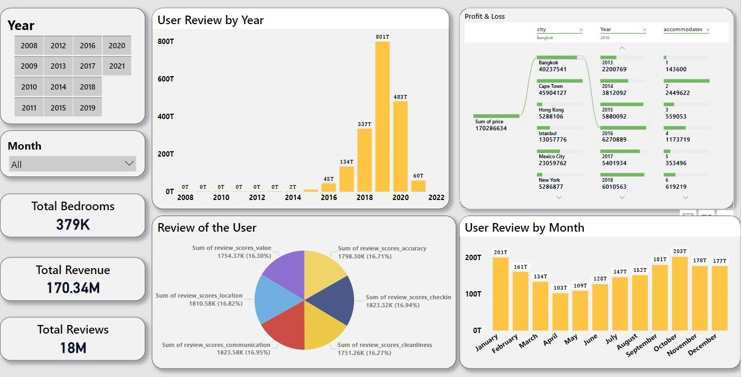

This Page Shows the Report of the Reviews of the People that has been provided by the user.

* In the Year of 2019, maximum number of Reviews has been given by the user, in the year 2019 October has the greatest number of reviews received.
* The reviews are basically given on the basis of accuracy, check in, cleanliness, communication, location, value.
* The total reviews received are 18M.
* The Maximum reviews are being posted for the Cleanliness.
* It is very important to record the Customer Satisfaction as it helps to develop the business and it also helps in learning new things.
* Customer Satisfaction plays a very vital role in development of a Business.
* In the year 2016 has the highest profit received in the city Bangkok with an Accommodation of 2 people in a room.
* The Total Revenue collected is Around $170M.

I came across Agoda free datasets and I found it looked interesting to work with. I conducted an exploratory data analysis including three dimensions: **Business Performance, Customer Satisfaction, and Host Growth**. Surprisingly, Paris city has a high customer engagement, and satisfaction contributes to better value for travels.

Takeaway from the visualization:

* High demand of the Host drives up prices in July before the year-end rush in December and January. Prices and demand drop are dramatically in March- June, during the Start of the Summer.
* Among 10 major cities, Paris City is the most loved cities by Agoda users. It provides the best value for money at 8/10 value ratings and 85% overall ratings with lower Room Price and Demand of Most Luxurious rooms with Affordable price.
* The most important features affecting the overall score are Wi-fi, the Essentials, long-term stays allowed and kitchen.
* The host in Paris City also offers the quickest Host Response Time.
* Maximum Night Stays & the location of the hotel in right place Allowed helped the user to provide good Reviews.
* Along with expanding its business and numbers, Agoda needs to really pay attention to Customer feedback and reviews as it’s the service offering industry. Also, it needs to bring in more stringent offline quality control mechanisms on-board to manage customer experience and keep the brand growing.